STUDENT LAB RECORD MARKS MANAGEMENT SYSTEM

Abstract
The Student Marks Management System is a console-based application developed using C++ to manage and analyze student academic records efficiently. In educational institutions, maintaining student marks manually is time-consuming and may lead to mistakes in record keeping, calculations, and retrieval of information. This system provides a simple digital solution for storing and processing student experiment marks.
The application stores student roll numbers and marks obtained in 10 experiments. Each student record is uniquely identified by a roll number, allowing quick access to the required information. The system uses a search operation to locate a student's record. Once the record is found, the user can either view the marks obtained in a specific experiment or calculate the average marks of a selected range of experiments.
The project demonstrates the use of structures, arrays, loops, functions, conditional statements, and searching algorithms in C++. Random marks are generated for simulation purposes, making the system useful for testing and demonstration. This project helps in understanding how programming can be applied to academic record management systems.
Overall, the Student Marks Management System provides an efficient, simple, and user-friendly way of maintaining student marks digitally while reducing manual effort and improving accuracy.
Introduction
In the present educational environment, managing student academic records is one of the important administrative tasks. Student performance is evaluated through experiments, assignments, tests, and examinations. Recording and processing these marks manually requires significant effort and increases the possibility of errors. A computerized system can simplify this process by automating storage, searching, and calculation of student marks.
The Student Marks Management System is designed as a simple academic management tool developed in C++. The main purpose of this project is to store student roll numbers along with their experiment marks and provide facilities to retrieve and analyze those records efficiently.
This system automatically generates student roll numbers and assigns marks for ten experiments. The user can search for a particular student using the roll number. Once the student record is located, the system allows the user to:

View marks obtained in a specific experiment.
Calculate average marks for a selected number of experiments.
Continue searching multiple student records until the user exits.
The project uses core programming concepts such as:
Structures for record storage.
Arrays for storing marks.
Functions for searching student records.
Loops for repetition.
Conditional statements for decision making.
This project serves as a basic model for larger educational management software systems.

Algorithm
Algorithm for Student Marks Management System
Step 1: Start the program.
Step 2: Define a structure named Student containing:
Roll Number
Marks array for 10 experiments
Step 3: Create a suffix array for generating unique roll numbers.
Step 4: Calculate the total number of students.
Step 5: Create an array of Student records.
Step 6: Initialize student records:
Assign roll number.
Generate random marks between 0 and 100.
Step 7: Ask the user to enter a student roll number.
Step 8: Search the roll number using linear search.
Step 9: If record not found:
Display "Record Not Found"

Step 10: If record found: Display options:
Experiment Marks
Average Marks
Step 11: If user selects Experiment Marks:
Ask for experiment number.
Display corresponding marks.
Step 12: If user selects Average:
Ask for number of experiments.
Calculate average.
Display average marks.
Step 13: Ask user whether to continue or exit.
Step 14: If continue = 1, repeat process.
Step 15: Stop the program.

Flowchart
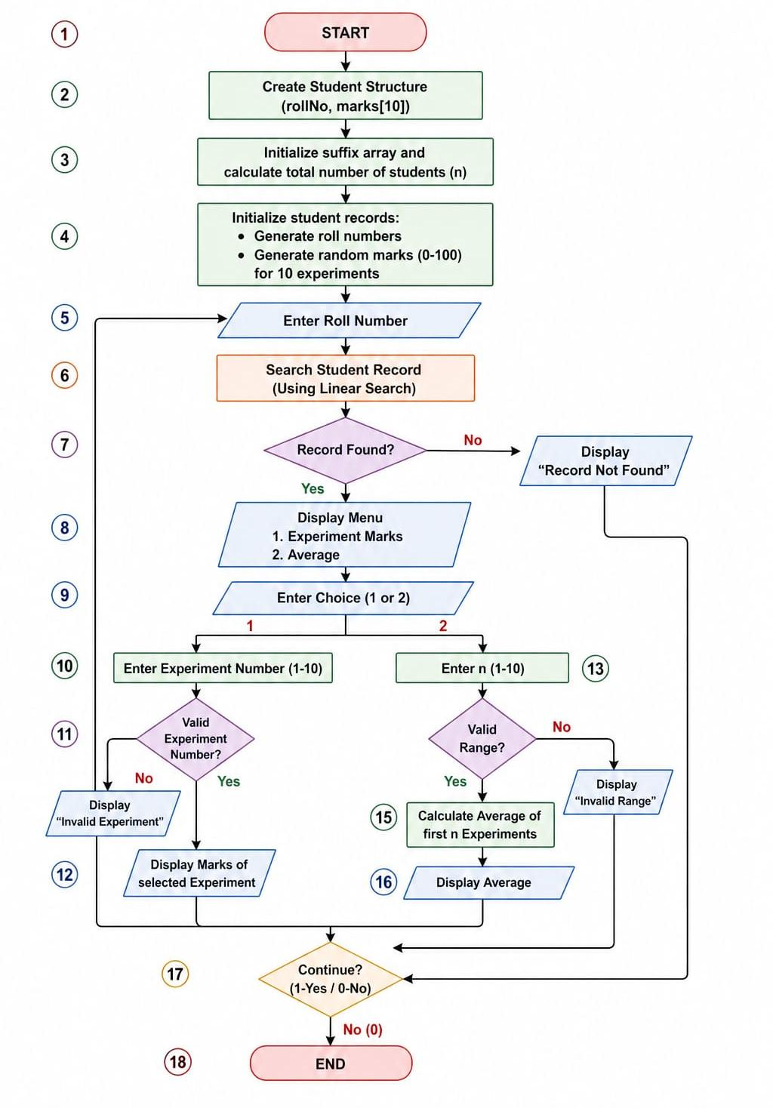

Methodology
The development of Student Marks Management System follows a structured methodology:
Requirement Analysis -
The system requirements were identified:
Store student records.
Search student by roll number.
Display experiment marks.
Calculate average marks.
System Design -
A Student structure is created containing:
Roll Number
Marks array
Implementation -
The program is divided into modules:
Data Initialization Module
Search Module
Marks Display Module
Average Calculation Module
User Interaction Module
Searching Technique -
Linear Search is used:
Compare input roll number with stored records.
Return index if found.
Return -1 if not found.
Processing -
If record exists:
Perform requested operation.
Display result.

Validation -
The system validates:
Experiment number range
Average range
Menu choice
Testing -
System tested for:
Valid roll number
Invalid roll number
Experiment marks retrieval
Average calculation
Continue/Exit operation

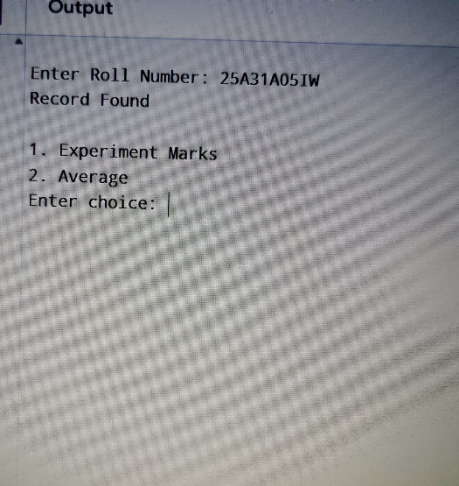
Result
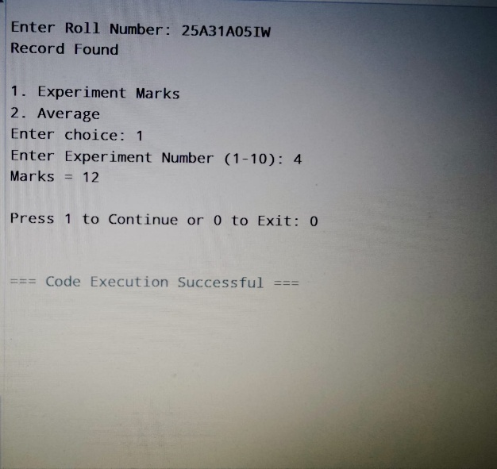

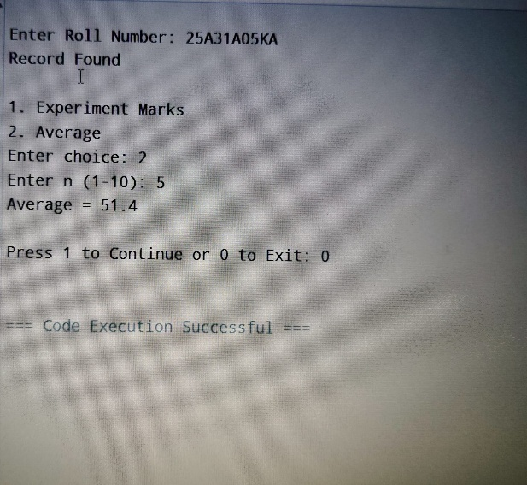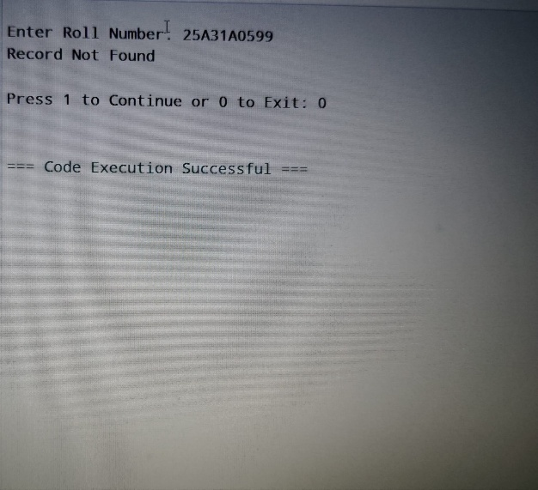
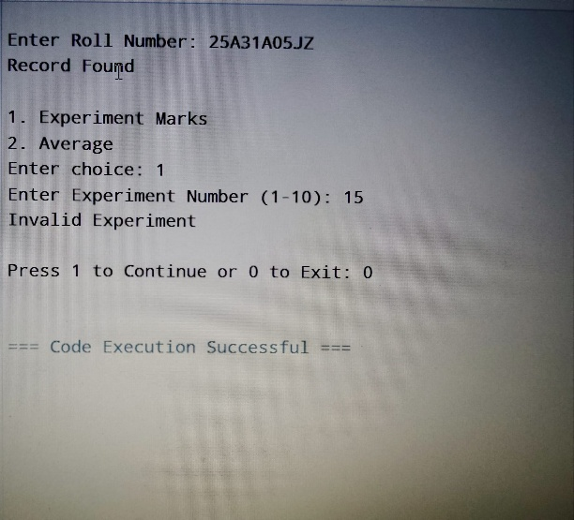
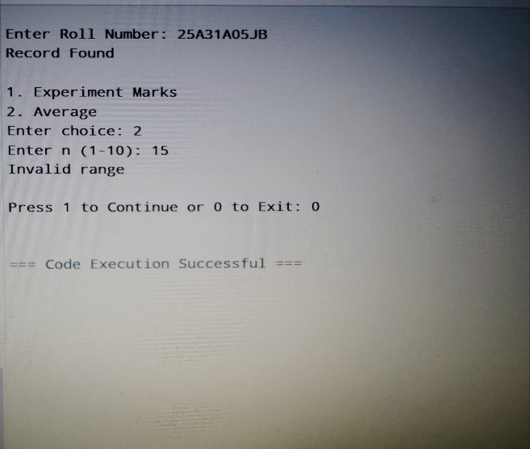

Conclusion
The Student Marks Management System is a simple and effective application developed in C++ for managing student academic records digitally. This project successfully demonstrates how programming can be used to organize, store, search, and process student marks in a systematic manner. By replacing manual record handling with a computerized system, the project reduces the chances of errors, saves time, and improves efficiency in maintaining academic data.
The system is capable of generating student roll numbers, assigning marks for ten experiments, searching student records using roll number, displaying marks for a selected experiment, and calculating the average marks of a specified number of experiments. These features make the system useful for basic academic record management and performance evaluation.
From the implementation of this project, important programming concepts such as structures, arrays, functions, loops, conditional statements, searching algorithms, and user interaction are effectively demonstrated. The use of Linear Search enables quick retrieval of records, while input validation ensures proper functioning of the system.
Overall, the Student Marks Management System provides a strong foundation for developing larger and more advanced educational software applications. It is user-friendly, easy to understand, and serves as an excellent learning project for understanding real-world applications of C++ programming in academic management systems.

Future Work
The current Student Marks Management System is a basic console-based application developed for storing and managing student experiment marks. Although it performs its intended functions effectively, there is significant scope for improvement and expansion in the future to make the system more advanced, user-friendly, and suitable for real-world academic environments.
1. Database Integration
Currently, student records are stored temporarily in program memory. In future, a database such as MySQL, SQLite, or Oracle can be integrated to store records permanently, allowing data to be saved even after the program is closed.
2. Addition of Student Details
The system can be expanded to include more student information such as:
Student Name
Branch / Department
Year / Semester
Section
Contact Details
Attendance Percentage
This will make the record system more complete.
3. Grade Calculation
Instead of displaying only marks and averages, the system can automatically calculate:
Grades (A, B, C, etc.)
Pass / Fail status

Percentage of mark
GPA / CGPA
This will help in better academic evaluation.
4. Ranking and Performance Analysis
Future versions can include:
Class topper identification
Subject-wise highest marks
Lowest marks
Rank list generation
Performance comparison charts
This helps analyze student progress.
5. Sorting and Filtering
The system can be improved by adding sorting features such as:
Sort by Roll Number
Sort by Marks
Sort by Average
Filter top-performing students
This makes data retrieval easier.
6. Graphical User Interface (GUI)
A GUI-based version can be developed using:
C++ Qt
Java Swing
Python Tkinter
Web technologies (HTML, CSS, JavaScript)
This will improve usability compared to a console-based application.
7. Authentication and Security
Login systems can be added for:
Administrator login
Faculty login
Student login
This ensures data privacy and secure access.
8. Report Generation
The system can automatically generate:
Report Cards
PDF files
Excel sheets
Semester progress reports
This reduces manual documentation work.
9. Cloud-Based Access
In future, records can be stored in cloud databases, allowing students and faculty to access academic records from anywhere.
10. Mobile Application Development
A mobile app version can be developed so students can check marks and performance easily through smartphones.

